**DATA PRE-PROCESSING STEPS**

**STEP 1: Load the dataset in R**

**STEP 2: Check for null values in the dataset**

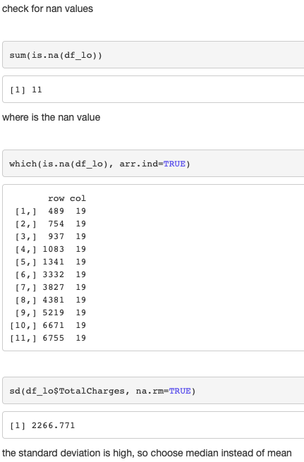

**STEP 3: We had 11 null values in the dataset and found the column which had null values.**

**STEP 4: The column total charges has null all the null values so replaced that with the median value of the column.**

**STEP 5: After replaced checked whether all the values have been replaced or not.**

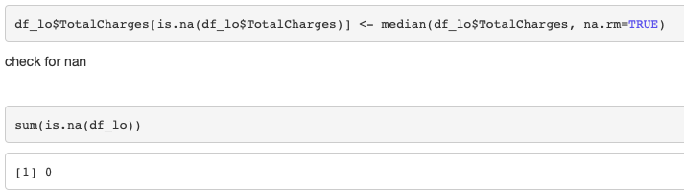

**STEP 5: Performed feature importance to see the important features for the target variable churn.**

